Toward a Geography-Free Model of International Competition

# David Masad

# CSS 625: Complexity Theory in the Social Sciences

05/12/2014

ABSTRACT

Most computational models of international relations are composed of grids of squares or hexagons; agents control contiguous territory of cells, and can only interact with agents controlling adjacent cells. In this paper, I present a geography-free model of an international system. Actors control abstract interests, which are activated and competed over at random.

Four experiments are undertaken, varying the initial conditions and the rule for resolving conflicting interests. For each experiment, I present a sample run of the model, and compute the Gini coefficient and a power law fit for the distribution of interests at each step of the model.

I show that each experiment exhibits different dynamics, but that they nevertheless all robustly converge on a unipolar system where there is only a single dominant actor. This differs from previous international relations models, and corresponds to some international relations theories on the globalizing, post-Cold War world.

# Introduction

The international political system exhibits many features of **complexity** (Geller 2011). Undoubtedly, the international system consists of numerous heterogeneous independent agents (primarily states, though not exclusively) interacting with one another in a decentralized manner through various forms of cooperation and competition. More formally, **power laws**, a hallmark of complexity (Cioffi-Revilla 2008), appear in various places in international relations; most famously in the distribution of the magnitude of wars (Richardson 1948; Cioffi-Revilla 2008), but also in the distribution of event data (Schrodt 2008).

It is no surprise that computer simulations, and in particular **agent-based models**, have been applied to the study of international relations. These efforts began prior to the emergence of the complexity paradigm, with models such as Benson 1961, Bremer and Mihalka 1977, and Cusack and Stoll 1990. However, complexity theory helped highlight that the rich behaviors and outcomes observed in the international system may be the result of relatively simple rules. This, combined with the increasing power and availability of computing resources, led to a new wave of agent-based models: most notably the GeoSim model family (Cederman 1997; Cederman 2003), but also AWorld (Min 2002; Min et al. 2008) and others.

The majority of these models have not attempted to replicate the actual actors and topology of the international system. Rather, they feature simplified agents in an abstract world. The GeoSim models use a simple square grid, while AWorld follows Bremer and Mihalka (1977) in using hexagonal cells. In both cases, the cells are the model’s fundumental unit: each cell represents a proto-polity, initially autonomous until taken over by another agent and integrated into their control. Importantly, the grid topology governs which agents may engage with one another; the models feature little or no long-distance interactions, and agents interact only with their immediate geographic neighbors. Cells are the source of resouces (and hence power), and conflict is exclusively over their control.

While geography certainly plays a role in real-world interactions (hence ‘geopolitics’), it is not as strictly limiting as these models assume. International trade is often explained with a ‘gravity model’ (Porojan 2001), where trade volume is both a function of the size of the economies and their geographic distance – implying, among other things, that major powers with larger economies are more likely to have longer-distance trade relations than smaller actors. Furthermore, conflict is not restricted to control over territory: states have a wide range of economic and other interests which they compete over (Huntington 1993; Moravcsik 1997).

In this paper, I present a new model of an international system, one that attempts to assess the role that geography plays by removing it entirely. Rather than have agents compete over cells on a grid, they compete for control of abstract ‘interests’, with unbounded interactions. In the remainder of this paper, I present this ‘zero-geography’ model in more detail, and describe the outputs of experiments utilizing several sets of initial conditions. I then discuss the broader implications of the model, compared to previous models as well as the real world.

# Method of Analysis

## Model Assumptions

I introduce an initial implementation of a geography-free model of an international system. The model attempts to capture the following assumptions:

1. The world is composed of political actors, endowed with resources and competing with each other for the means to acquire additional resources.
2. Actors’ interactions with one another are driven by specific interests, which become salient exogenously.
3. All actors have loss aversion, and will prioritize defending their current interests over expanding their influence.
4. Strong actors will tend to act more frequently than weak actors, and interact with a wider range of actors.
5. Strong actors will generally have an advantage over weak ones.
6. Weak actors may nevertheless be able to defeat stronger actors over issues that are much more salient to the weak actor than the stronger one.
7. Weak actors with no ability to gain additional resources cease to be relevant actors.

These assumptions are generally similar to the driving assumptions of the geopolitical models described above, particularly GeoSim. Like GeoSim, the model as implemented here does not include alliances. As argued by Min et al. (2008), alliances represent an important component of an international system, and one which is likely to influence the outcomes significantly; as such, a detailed aspatial alliance model is outside the scope of this paper. However, as (Cederman 1997) demonstrates, many features of an international system may emerge even in the absence of alliances.

## Model description

Formally, the model is composed of two types of entitites: **Actors** and **Interests**. Interests are activated (become salient) at random, allowing their owners to expend resources to protect their own interests and attempt to dominate the other’s. Finally, actors gain resources based on the interests they currently control.

### Interests and Actors

Interests take the role that provinces play in GeoSim and AWorld; they are the atomic entities from which actors are assembled. Each interest is owned by exactly one actor at any given time. Whereas provinces represent discrete geographic entities, interests are meant to be more abstract: they may represent a piece of geography, but also access to a natural resource, an international institution, or even a source of ‘soft power’ (Nye 2004) or social capital; in short, any source of power in an international system.

Actors represent primarily states, though they may be any autonomous actor in an international system, including non-governmental advocacy organizations, transnational militants, and more. Actors must posess at least one interest in order to be active. They are endowed with an abstract measure of power and influence (which I will call *wealth*) based on the interests they control, and which they expend in defense of their current interests and in the acquisition of new ones.

### Model Step

The model proceeds in **ticks**, with each tick representing an interaction between (generally) two actors. A tick proceeds as follows:

1. Two interests are chosen uniformly at random to become active.
2. The actors who control these interests are activated.
   1. If both actors have only one interest, they merge together, combining both interests and wealths.
   2. If at least one actor has two or more interests, both actors simultaneously allocate wealth toward both active interests based on the decision rule described below. This wealth is subtracted from the actors’ endowment of wealth. The actor who allocated the most wealth to each interest gains or maintains control of it.
   3. If both interests are owned by the same actor, this represents **internal conflict**, which is described below.

After one interaction concludes, two more interests are activated at random, beginning the next interaction. Additionally, after every set number of interactions, all actors gain resources based on the total value of interests they currently control. This is a model **step.**

Note that there is no reason to assume that interactions represent evenly spaced time-steps; rather, they represent opportunites for change in the world. Thus, unrelated interactions (i.e. ones with no overlapping interests or actors) may even be taking place simultaneously, while other interactions may represent events occuring days, weeks or months apart.

### Actor Decisionmaking

Most interactions involve interests owned by two different actors. From the perspective of each actor, they are defending the interest they own and attacking the other’s interest. The actors allocate wealth to each in proportion to its fraction of their total wealth.

Formally, let and designate the actors, with and their respective wealths. Actor has interests, with their values designated through . Let be the interest is defending, and the interest owned by which is attacking. The wealth allocated to each interest is:

(1)

(2)

This decision rule corresponds to assumptions 3-6, as described above. The more wealth an actor has, the more, in absolute terms, they will be able to allocate to both active interests. However, a to high-wealth actor, a given interest may represent only a small fraction of their total interests, and thus they may allocate fewer resources toward it. An actor with a single interest, in contrast, will always devote *all* its wealth to defending it. Note also that given two interests of identical value, the rules above ensure that actors will allocate more resources to defending the interest they own over an identically-valued interest they are attacking.

### Internal Conflict

As actors accumulate more interests, the chances increase that two interests will become activated which both belong to the same actor. This captures the issue of internal conflict: as political actors grow and expand to include more diverse interests, the chances that these interests will come into conflict increases.

I experiment with two different mechanisms for resolving internal conflicts:

* **Internal resolution** simply requires the owner to expend wealth to defend both interests, following the rule described above. This represents the actor expending resources to resolve the conflict and maintain the status quo.
* **External resolution** assumes that the conflict may only be resolved by jettisoning one of the conflicting interests. Under this rule, the lower-valued interest is removed from the actor, becoming an independent actor with initial wealth equal to what the original owner would have expended defending it.

These are highly simplified rules, which only correspond to some ways such conflicts are resolved in reality. However, they are sufficiently different from one another as to facilitate experiments capturing the qualitative extremes.

## Model Setup

I run four experiments, varying the internal conflict mechanisms and the initial conditions. The first model initialization involves 100 interests; each is initially a singleton, an agent associated associated with a single agent. This represents a ‘cold start’ where aggregate actors have not yet formed. The second initialization can be thought of as burned-in, with higher resolution: it involves 1,000 interests, distributed randomly among 100 actors. This represents a ‘more complex’ system (in the social-complexity sense), where actors are already aggregations of interests, with each specific interest having reduced bearing on the system as a whole.

|  |  |  |
| --- | --- | --- |
|  | **Internal Resolution** | **External Resolution** |
| **Cold Initialization** | Experiment 1 | Experiment 2 |
| **Burn-In Initialization** | Experiment 3 | Experiment 3 |

Each combination of internal conflict mechanism and initialialization constitutes an experiment, for 4 experiments total. Each experiment involves 100 random model instantiations. The cold-start models are run for 1,000 steps, while the burn-in models are run for 10,000 steps. Across all models, interests are created with a random value selected from a uniform random distribution of the integers between 1 and 100.

## Analysis

For each experiment, I will present a representative run, including the initial and final distributions of interests among agents, and the change in the number of active agents over time.

At each step of each run, I will compute the Gini coefficient (Yitzhaki 1979) of the distribution of interests across all active agents. This will provide a normalized way of assessing how concentrated or dispursed ownership of interests (and hence power) is within the system. By plotting the Gini coefficents of all runs in each experiment together, I will visualize overall patterns that each system converges to, as well as any deviations from them.

Finally, I will fit a Type III power law (Cioffi-Revilla 2014) of the form

(3)

to the distribution of interests at each timestep of each model run. Note that initially, when the distribution of interests is approximately uniform, a power law will be a poor fit – it will not in fact describe the distribution. Nevertheless, by plotting the best-fit power law coefficient at each step, we will be able to identify the **phase shift** occuring if and when the system converges to a **heavy-tailed distribution**.

# Results and Findings

## Experiment 1

The models under this experiment exhibit convergence toward strong consolidation into a single actor. Figure 1 shows a representative run of the model. Initially, the number of actors plummets rapidly as singletons consolidate together. Past an inflection point, all or most of the actors are likely aggregate, multi-interest entities, and the consolidation continues at a slower pace. Even the period of bipolarity, with two actors, does not last long, and the model converges to a single actor.

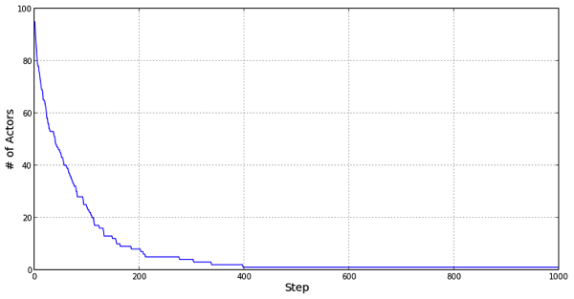

(c) Actor count series

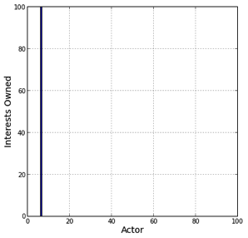

(b) Final distribution

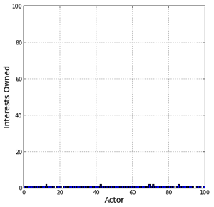

(a) Initial distribution

Figure 1: Experiment 1 sample run

This pattern is robust across all runs of this experiment. Figure 2 shows the Gini coefficient from all model runs plotted together, and demonstrates that they all exhibit a very similar dynamic. All runs exhibit rapid initial consolidation; while there is some variation in the pace at which the number of actors narrows, by shortly after step 200, all model runs have consolidated into a single actor, as indicated by the Gini coefficient of 1.

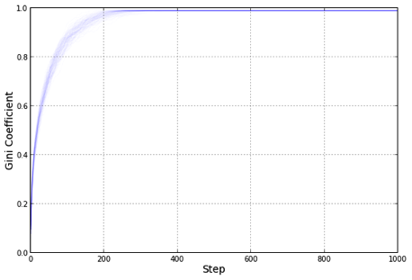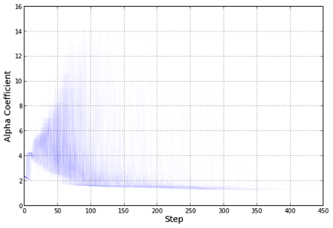

Figure 2: Experiment 1 Gini coefficients

Figure 3: Experiment 1 Alpha coefficients

Figure 3 shows the fitted parameter across each run. During the period of consolidation, a power law is often a poor fit, and the fitted parameter takes on a wide range of values we would not expect to observe in a real power law. Nevertheless, as the model converges toward a small number of actors, the weight of the distribution of s begins to accumulate on plausible values slightly below 2. This strongly suggests that at this point, even the apparently multipolarity suggested by the counts of interests per actor is misleading: there is already likely to be one actor with the bulk of interests, while the actors who remain are substantially smaller, and hence weaker. Here, the appearance of the plausible scale-free distribution helps indicate when the system begins to become unipolar. Note the maximum value of the x-axis in Figure 3; once there is only one actor remaining, there cannot be a distribution of interests, and thus no distribution parameter.

## Experiment 2

This experiment uses the external resolution rule described above, and hence features a new potential phenomenon not exhibited in the previous experiment: the appearance of new actors. This is demonstrated by the representative run in Figure 4: initially, the model behaves very much as in the previous experiment, with a rapid consolidation of interests. However, at a certain point, a new process takes over, and the number of actors begins to fluctuate, showing cyclic-seeming behavior but overall remaining stably higher than the previous minima. Note the distribution of interests, shown in Figure 4(b). While the end state exhibits many actors, all but one control no more than 5 interests, with most only controlling one or two; there is a single actor dominating the system and dominating nearly half the interests within it.

The Gini coefficients across runs (Figure 5) confirm this. While the curve appears shallower than in the previous experiment (and never reaches 1), it shows a very similar trajectory, with a period of rapid consolidation followed by a slower convergence toward a single unitary actor. Note that the fluctuations that characterize the actor count are completely absent from the Gini charts. There is still a dominant actor; while new actors appear due to internal conflict, and some may survive and even combine with other cast-off interests, none grow large enough to change the balance of power.

Figure 4: Experiment 2 sample run

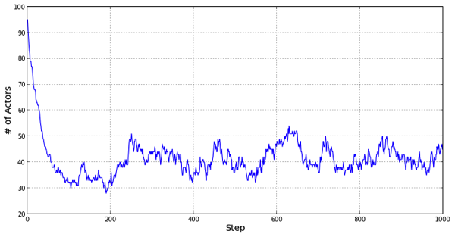

(c) Actor count series

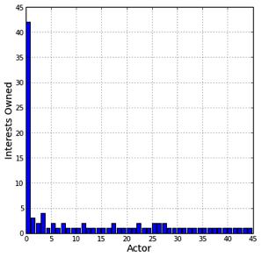

(a) Final distribution

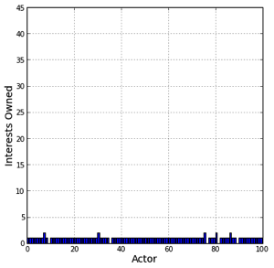

(a) Initial distribution

Like the previous experiment, the power law fit is initially weak, as shown in Figure 6. However, to a greater extent than in the previous experiment, this model appears to exhibit a strong phase shift, converging to a coefficient close to 2, though making regular, frequent jumps above it, while always staying below 3. This appears to be the state where there is one dominant actor, surrounding by a ‘foam’ of actors cast off of the dominant actor due to internal conflict, consolidating with others, and ultimately being reabsorbed by the dominant actor.

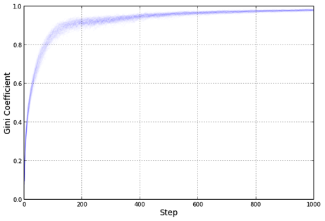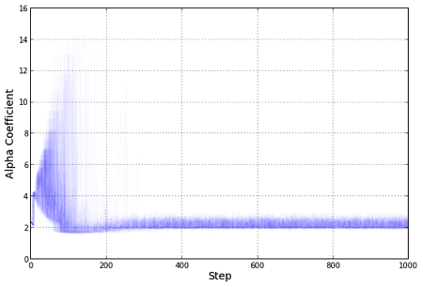

Figure 5. Experiment 2 Gini coefficients

Figure 6. Experiment 2 Alpha coefficients

## 

## Experiment 3

This experiment uses the internal resolution rule used in Experiment 1. Unlike it, however, it is initialized ‘burned-in’, with 1,000 interests divided randomly among 100 actors. We may naively expect this experiment to have similar dynamics to those observed in Experiment 1, and indeed they are similar in one key respect – the internal resolution rule means that the number of actors may only go down. Nevertheless, the trajectory by which the number of actors declines is clearly different, as the representative run in Figure 7 shows. While the model still converges to a single all-encompassing actor, the rate of convergence appears to be essentially linear.

The Gini coefficients plotted in Figure 8 show similar dynamics. While they are not quite as linear as Figure 7(c), they nevertheless do not exhibit the inflection point in both previous Gini plots.

Figure 7: Experiment 3 sample run

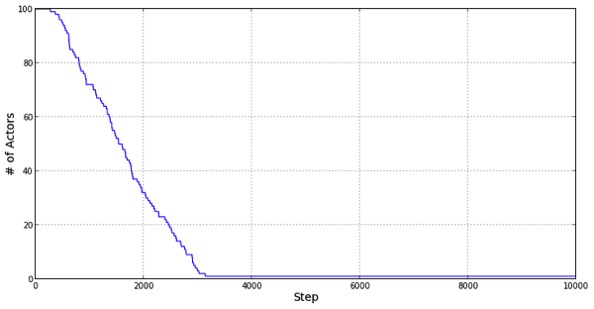

(c) Actor count series

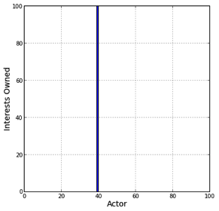

(a) Final distribution

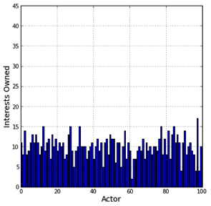

(a) Initial distribution

Similarly, the power law coefficient in Figure 8 does not exhibit a phase shift. In fact, unlike in the previous experiments, the bulk of the distribution is not on a plausible power-law coefficient, though there is a general trend toward convergence.

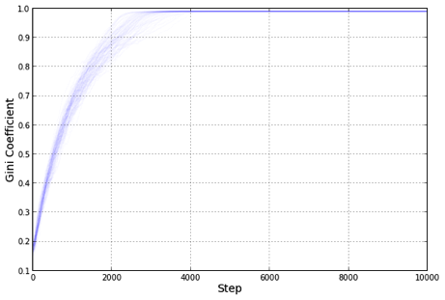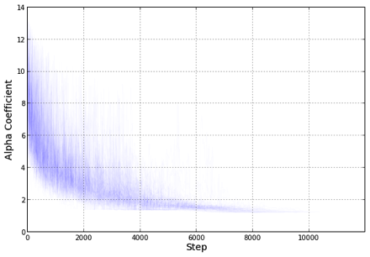

Figure 8. Experiment 8 Gini coefficients

Figure 9. Experiment 8 Alpha coefficients

## 

## Experiment 4

The results of this experiment show perhaps the most striking results. The representative run showed in Figure 10 shows not just one phase shift but two. There is an initial relatively steady increase in the number of actors, until approximately step 1,500, when the rate at which new actors appears suddenly spikes, rapidly increasing until shortly after step 2,000, when the number of agents stabilizes, beginning to randomly oscillate around 400 actors, a state which persists throughout the rest of the model run.

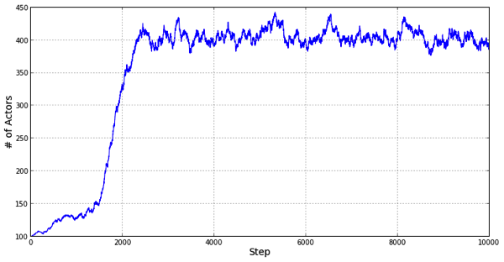

(c) Actor count series

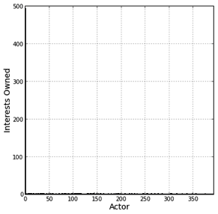

(a) Final distribution

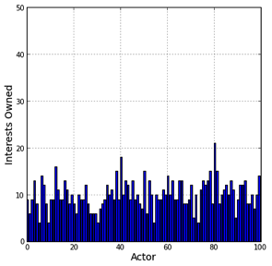

(a) Initial distribution

Figure 10: Experiment 4 sample run

The Gini coefficient plot (Figure 11) shows a similar kink, unseen in any of the previous Gini plots. Robustly, across multiple runs, the Gini coefficient rises, then dips, bottoms out, and increases again, slowly approaching 1 though never fully converging.

The power law coefficient plot shows a similar kink; the wide, downward-sloping initial behavior resembles Experiment 3; it is followed by a dramatic, near-discontinuous jump, and an stable equilibrium slightly above 3, a plausible though high power law coefficient.

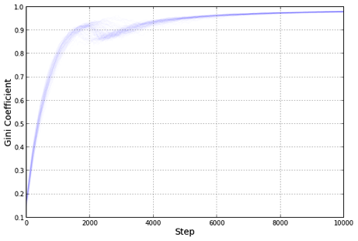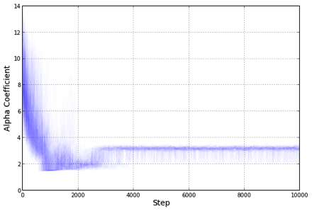

Figure 11. Experiment 4 Gini coefficients

Figure 12. Experiment 4 Alpha coefficients

# Discussion

We can analyze the behavior of this model along two lines. While the previous section discusses the results in a self-contained manner, we must remember that our original intent was to simulate an international system; thus, the model results ought to be able to tell us something about international relations. Additionally, the model presents and illustrates several broader issues in the behavior of complex systems, and the challenges involved in modeling and analyzing them.

There is one key force which exhibits itself across all the model runs presented above, regardless of the experiment: a strong tendency towards unipolarity. All the model runs begin with a relatively equitable distribution of interests – and hence of resources and power. Yet by the end of each and every model run, a single actor will have emerged as the sole ‘superpower’, controlling a disproportionate number of interests. Under the internal conflict resolution rules, no new actors are inserted into the model, leading to only a single actor remaining active. Yet even under the external rule, when new actors appear regularly, the superpower ends up controlling nearly 50% of all interests, while none of the remaining actors control more than a handful each. This suggests that the convergence to unipolarity is not merely a function of the one-way movement of actor counts under the internal rule, but an **emergent** result of the system as a whole.

Indeed, it is easy to see how this process occurs. Actor resources exhibit **positive feedback**: as an actor gains control of additional interests, it acquires more resources, which make it more likely to gain control of yet more interests. At some point, an actor may cross an event horizon of sorts, by which it has accumulated sufficient wealth to devote more resources to any interest than any other actor can. Similarly, actors with fewer or lower-valued interests will have less wealth to defend them with, making them more likely to lose control of those interests in any interaction.

As noted earlier, interests function similarly to provinces in previous models. Yet those models did not exhibit the strong convergence to unipolarity exhibited here. This helps point us toward a potential role that geography plays, and in particular the limitation of actors to local conflict only. In the geographic models, the set of potential interactions at any given time is limited. This provides multiple actors with a chance to grow strong by conquering their neighbors before coming into conflict with one another – local unipolarity giving rise to system-wide multipolarity. The geography-free model has no such constraint, allowing relatively powerful actors to come into conflict earlier, as well as competing for the same available resources (in the form of interests held by weaker actors) – with inevitable negative consequences for the loser.

The international relations literature has also drawn a connection between globalization and unipolarity. Most famously, perhaps, Fukuyama (2006) argued about the approaching “end of history” and the one-way (at least in the medium-term) convergence of ideology and governance toward a liberal democratic order. Weber et al. (2007) present the dangers they believe globalization-driven unipolarity has created. Interestingly, their first axiom is that “[a]bove a certain threshold of power, the rate at which new global problems are generated will exceed the rate at which old problems are fixed”; if we are to view singleton interests as ‘problems’, this description resembles the phase shift that occurs with the external resolution rule, most dramatically in Experiment 4.

A property of this model is that more powerful actors are more likely to be activated, which gives them additional opportunities to further increase their power. This property bears resemblence to another one found in many complex systems: preferential attachement. Particularly in network models, preferential attachement is known to drive the formation of scale-free networks, characterized by power-law distributions of degrees (Barabási and Albert 1999). In this case, number of interests only approximately resembles network degree, and indeed it appears that the distribution of interests, while frequently long-tailed, may not follow a strict power law. Nevertheless, it is noteworthy that across domains, qualitatively similar processes yield qualitatively similar results.

While the convergence to unipolarity is robust across all the experiments, many of the model’s other dynamics are not. In particular, the convergence process varied qualitatively between different initial conditions, model scales and resolution rules. It is not clear whether one set of initial conditions is more correct than others, particularly with a model like this where there is not a one-to-one mapping between model entities and the real world. It should not be surprising that in a complex system, initial conditions have a substantial effect not only on the outcome but on the dynamics – yet such variation has not been deeply explored in many previous geopolitical models.

While the geography-free assumption underlying this model is clearly a gross oversimplification, so too is the grid or hexagonal topologies of previous models of international systems. Yet as this analysis shows, the assumptions made about geography (and in particular its absence) have a substantial effect on the model outcomes. Thus, future geopolitical modeling efforts should experiment with different interaction topologies, and integrate long-range interactions. If the model results are robust to such interactions, it may be evidence to the robustness of the model as a whole, and the external validity of its results. However, if long-range interactions qualitatively alter the model outcome, it is important to make sure that any external assumptions derived from it are done using behaviors that match the real world.

# Summary

In this paper, I have presented a zero-geography model of an international system, in which actors are composed of, and compete for, heterogeous interest objects. It is intended to help assess the role of geography in models of the international system, and by extension in real-world international relations as well.

I find both similarities and differences among different initializations of the model. Robustly, across all runs of all initial configurations, the model converges to unipolarity; either there is only one actor remaining, or else a single actor controls the bulk of interests in the model, with no other actors coming close in size. This corresponds to some qualitative analysis of the globalized, post-Cold War order, albiet with far more extreme results.

Experiments 1, 2 and 4 all show evidence of at least one phase shift (two in Experiment 4) in the model dynamics, while Experiment 3 shows a relatively linear convergence. Nevertheless, all the experiments appear to have qualitatively different dynamics, despite converging to similar outcomes. These results highlight the nonlinear interactions between model behaviors and model scale. This in turn suggests that running such experiments with other, similar models is important as well: if the dynamics and results are strongly dependent on specific configurations, they may be less generalizeable to reality without additional evidence for the initial conditions’ appropriateness.

Of course, while real-world political interactions do not only occur across contiguous territory, neither do they occur without any reference to distance and geography. Future work will ultimately need to allow for both short-range and long-range interactions in order to capture the full complexity of the international system.

# References

Barabási, Albert-László, and Réka Albert. 1999. “Emergence of Scaling in Random Networks.” *Science* 286 (5439) (October): 509–512.

Benson, Oliver. 1961. “A Simple Diplomatic Game.” *International Politics and Foreign Policy, New York*: 504–511.

Bremer, Stuart A., and Michael Mihalka. 1977. “Machiavelli in Machina: Or Politics Among Hexagons.” *Problems of World Modeling*: 303–37.

Cederman, Lars-Erik. 1997. *Emergent Actors in World Politics*. Princeton University Press.

Cederman, Lars-Erik. 2003. “Modeling the Size of Wars: from Billiard Balls to Sandpiles.” *American Political Science Review* 97 (01): 135–150.

Cioffi-Revilla, Claudio. 2008. *Power Laws and Non-Equilibrium Distributions of Complexity in the Social Sciences*.

Cioffi-Revilla, Claudio. 2008. “Power Laws of Conflict: Scaling in Warfare and Terrorism.” 2008. In *Power Laws and Non-Equilibrium Distributions of Complexity in the Social Sciences*, edited by Claudio Cioffi-Revilla.

Cioffi-Revilla, Claudio. 2014. *Introduction to Computational Social Science*. Texts in Computer Science. London: Springer London.

Cusack, Thomas R., and Richard J. Stoll. 1990. *Exploring Realpolitik: Probing International Relations Theory with Computer Simulation*. Cambridge Univ Press.

Fukuyama, Francis. 2006. *The End of History and the Last Man*. Simon; Schuster.

Geller, Armando. 2011. “The Use of Complexity-Based Models in International Relations: a Technical Overview and Discussion of Prospects and Challenges.” *Cambridge Review of International Affairs* 24 (1): 63–80.

Huntington, Samuel P. 1993. “Why International Primacy Matters.” *International Security* 17 (4) (April): 68–83.

Min, Byoung Won. 2002. “Trade and War in Cellular Automata Worlds: A Computer Simulation of Interstate Interactions.” PhD thesis, United States – Ohio: The Ohio State University.

Min, Byoung Won, Richard Ned Lebow, and Brian M. Pollins. 2008. “War, Trade, and Power Laws in a Simulated World.” In *Power Laws and Non-Equilibrium Distributions of Complexity in the Social Sciences*, edited by Claudio Cioffi-Revilla.

Moravcsik, Andrew. 1997. “Taking Preferences Seriously: A Liberal Theory of International Politics.” *International Organization* 51 (4): 513–553.

Nye, Joseph S. 2004. *Soft Power: The Means to Success in World Politics*. PublicAffairs.

Porojan, A. 2001. “Trade Flows and Spatial Effects: The Gravity Model Revisited.” *Open Economies Review* 12 (3) (July): 265–280.

Richardson, Lewis F. 1948. “Variation of the Frequency of Fatal Quarrels with Magnitude.” *Journal of the American Statistical Association* 43 (244): 523–546.

Schrodt, Philip A. 2008. “Events Data Processes and Power Law Behavior in International Interactions.” In *Power Laws and Non-Equilibrium Distributions of Complexity in the Social Sciences*, edited by Claudio Cioffi-Revilla.

Weber, Steven, Naazneen Barma, Matthew Kroenig, and Ely Ratner. 2007. “How Globalization Went Bad.” *Foreign Policy* 158: 48–54.

Yitzhaki, Shlomo. 1979. “Relative Deprivation and the Gini Coefficient.” *The Quarterly Journal of Economics*: 321–324.